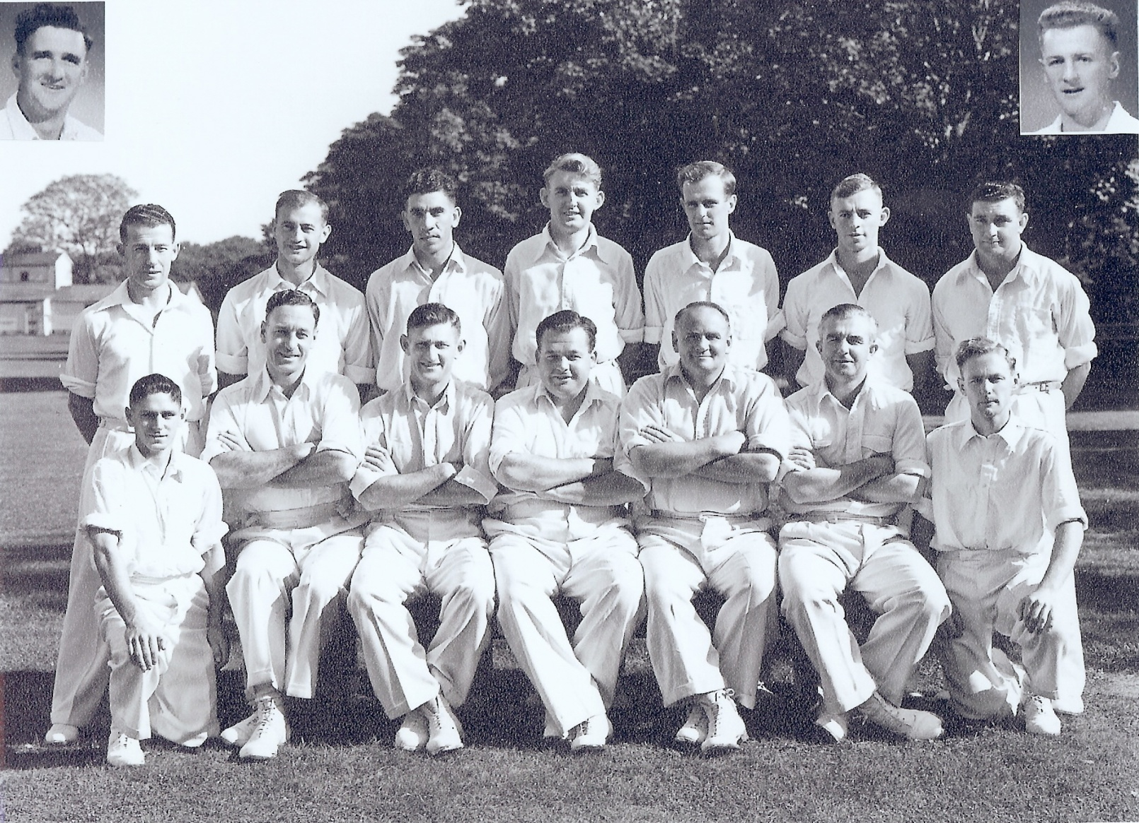

**Canterbury Representative Team 1953-54**

**Back row:** RT Dowker, PGZ Harris, SC Guillen, DJ Reid, DW Stark, IM Sinclair, GN Gearry

**Front row:** BA Haworth, RH Scott, JA Hayes, JG Leggat (captain), TB Burtt, RWG Emery, GE Royfee

**Inset:** PW O’Malley, P Arnold